LifeQI GUIDE -
Creating a Project

The purpose of this document is to provide a step-by-step guide for creating a project on LifeQI and appropriately assigning it to an organisational priority and tag. This document has been divided into two sections:
- Creating a new project
- Assigning priorities and tags to an already existing project
- Appendices

Creating a new project

- Login to your account on https://www.lifeqisystem.com.

- Enter the Projects area (via the menu on the left) and select start a new project.
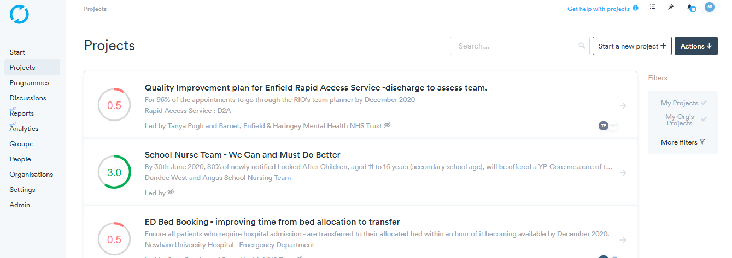

- Enter the project title and the problem that the project is intended to address.

- Enter the aim of the project and the rationale

- Invite the relevant members of the project and set the appropriate privacy settings for your project.

- Select your priorities and tags. These will theme your projects and make them easily identifiable.

  - Priorities are themes which are deemed to be organisational priorities

Select Link a priority and select the priority that is relevant to your project. You can repeat this step to add more than one priority if needed.

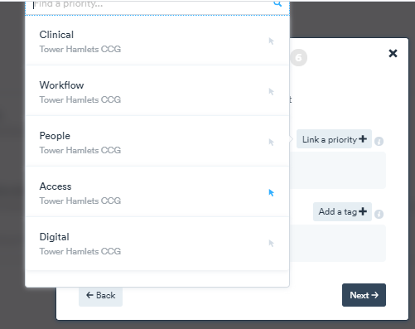

Here we have selected “Access” as the priority. To delete the priority you can click the bin symbol.

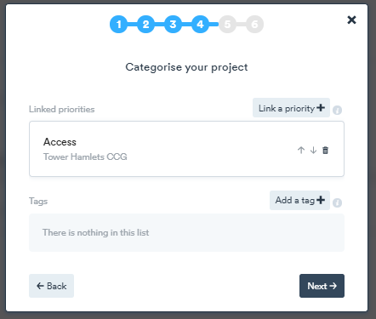

  - A tag is a sub-theme of the priority.

Select Add a tag and search for the relevant tag.

As part of EQUIP, it is recommended that you use the EQUIP tags. Type EQUIP in the search bar and select the relevant tag. If you cannot find a tag, you have the option to click “Can’t find a tag?” and create your own. Please ensure that you follow the same format as the EQUIP tags where “– EQUIP” follows the tag name.
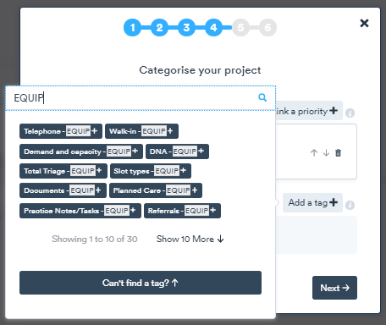

Here we have chosen “Telephone –EQUIP” as our tag. To delete the tag, click the “x” by the tag.
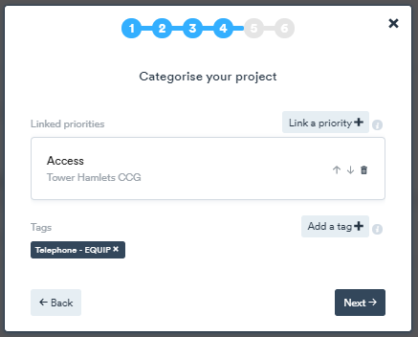

Examples of how to collaboratively add priorities and tag your projects can be found in the appendix.

- Select the planned duration of your project and state where the location will take place.
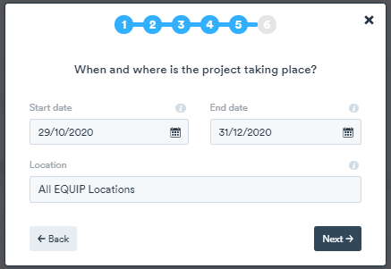

- Click Next and then click Create project.
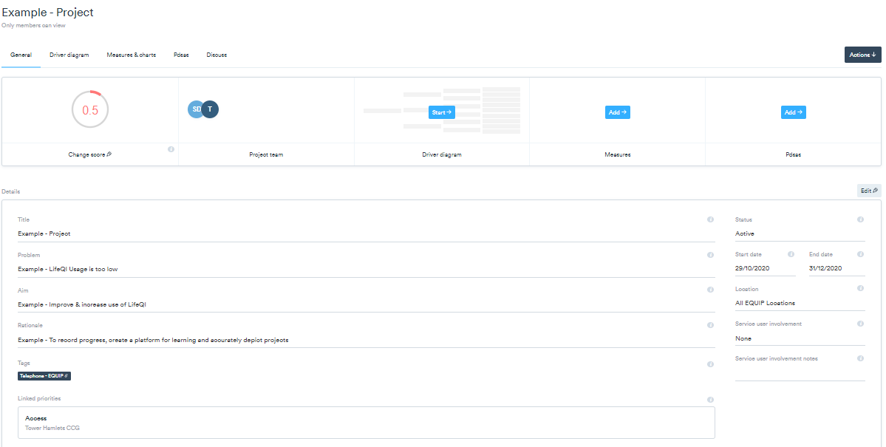
Your project has now been created

Assigning priorities and tags to an already existing project

If you already have a project and want to update you tags follow the steps below.
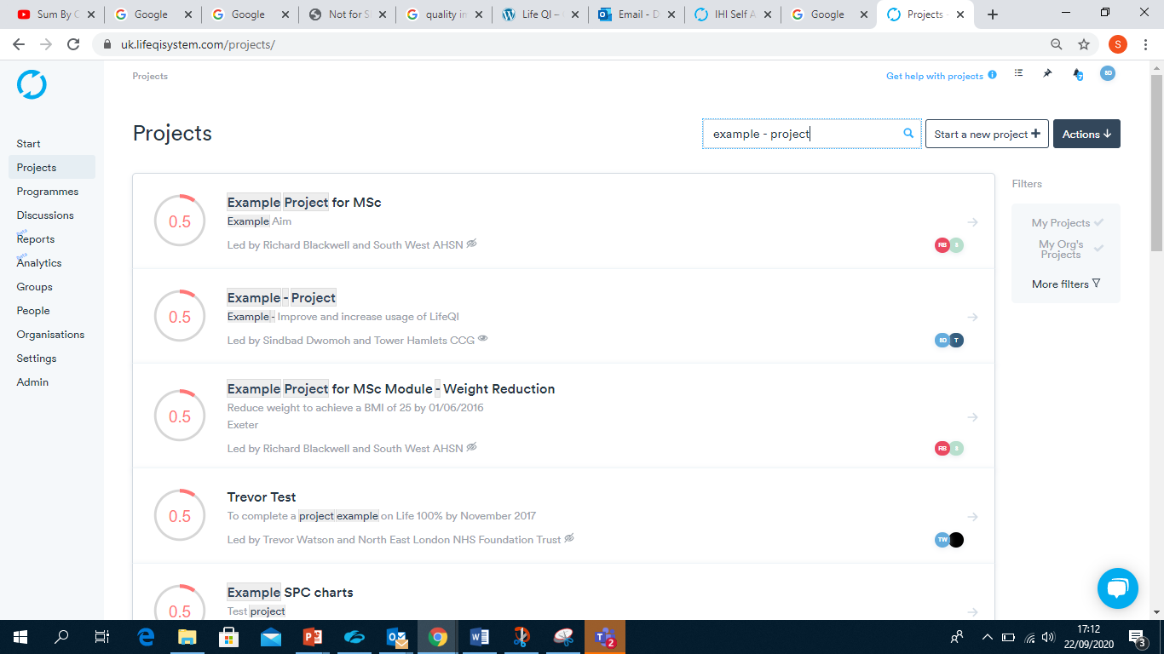
- Enter the Project area (via the menu on the left), search the name of your project (via the search bar at the top of the webpage) and click on your project.

- Once you are viewing your project, select Edit. The “Details” area below will now be susceptible to any edits you wish to make.

- You can now click Add a tag and/or Add a priority and follow the instructions in step 6 in the “Creating a new project” section above.
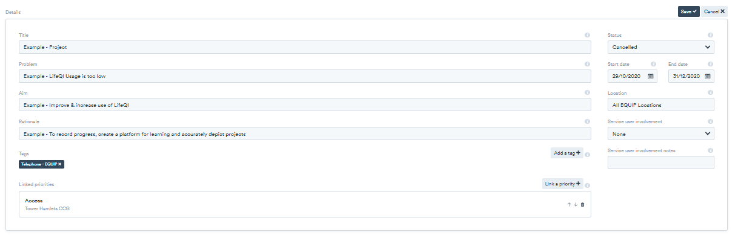

Appendix 1
The outer headings of the venn diagram represent the organisational priorities and the items within the venn diagram represent the EQUIP tags.

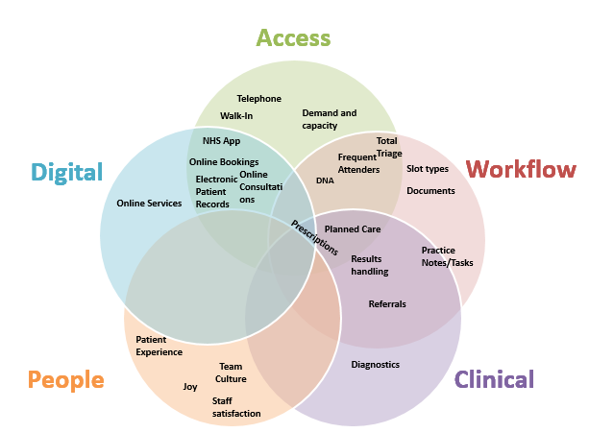

Version Control
Name | Email | Date | Version
Sindbad Dwomoh | s.dwomoh@nhs .net | 17/11/2020 | 1.0

