LifeQI GUIDE -
Project Status

The purpose of this document is to provide a step-by-step guide for closing and activating projects in LifeQI. The document has been divided into two sections:
- Deciding the status of your project – This section uses a flow diagram to help you determine which status is appropriate for your project, which you can the record on LifeQI.
- Recording the project status – This section is a step-by-step guide for how to update your project status on LifeQI.

Deciding the status of your project
What is the status of your project?

Cancelled
Completed
Active
Can the reason for cancellation be found on LifeQI (e.g. sufficient data, reason for cancellation statement in the “discuss” section)?
Can the evidence of completion be found on LifeQI (e.g. sufficient data, diagrams, change ideas, completion statement on the project timeline)?

Mark project as Active in LifeQI (if not already marked)

Yes
No
No
Yes

Mark project as Cancelled in LifeQI

Mark project as Complete in LifeQI

Provide reason for cancellation of projection
Provide evidence of project completion

Status Definitions:
Completed
- Project must have an IHI progress score of 3.0 or more. A score lower than 3.0 cannot warrant completion.
- Project must have achieved its aim and/or shown sustained improvement
- Information and data clearly demonstrates an improvement
Cancelled
- A closed a project that does not qualify as “completed”
  - This applies to both a permanent or temporary closure (e.g. due to long term absences)
Active
- A project that is still open and on going
Note: A project that was marked as “cancelled” due to a temporary closure should be marked as “active” once the project is ready to re-commence. The reason and date of project reactivation should be recorded on the project timeline section (see step 5 in Recording the project status on LifeQI section).

Recording the project status on LifeQI

- Login to your account on https://www.lifeqisystem.com.

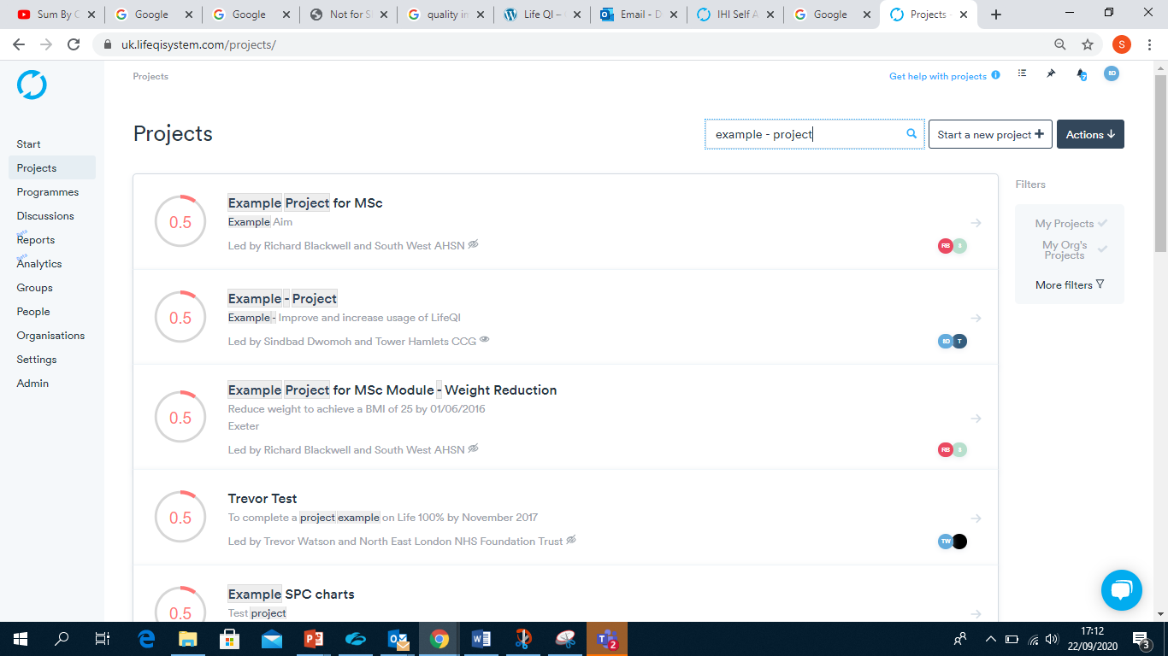
- Enter the Project area (via the menu on the left), search the name of your project (via the search bar at the top of the webpage) and click on your project.

- Once you are viewing your project, select Edit. The “Details” area below will now be succepitble to any edits you wish to make.
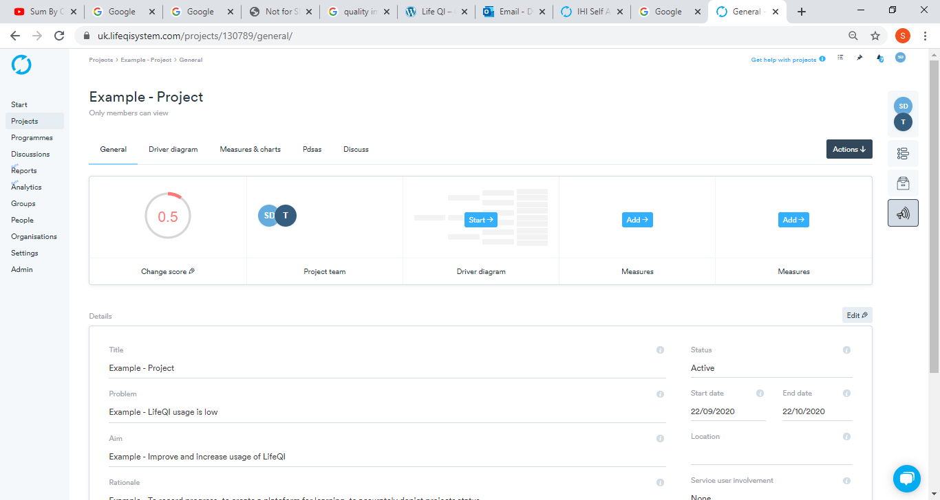

- Select the drop down menu for “Status” and click the project status required. For the example, we have chosen Cancelled. To ensure this change is recorded, click Save.
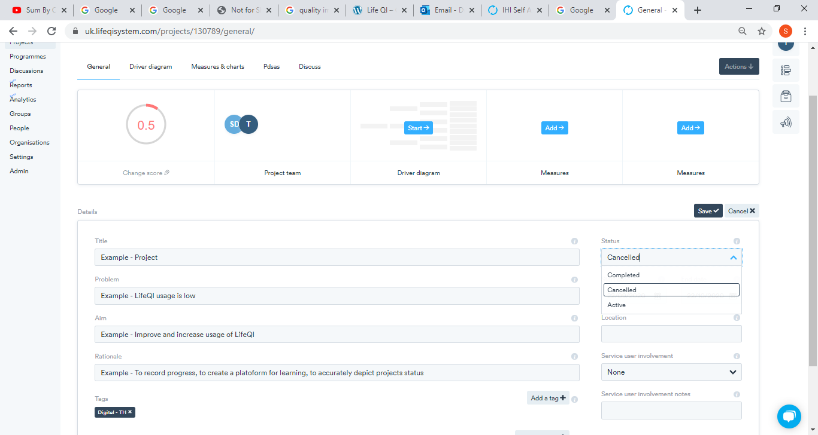

- In order to state our reason(s) for changing the project status (e.g. a completion statement, reason for cancelleation or (re-)activation of project), state this in the project timeline.

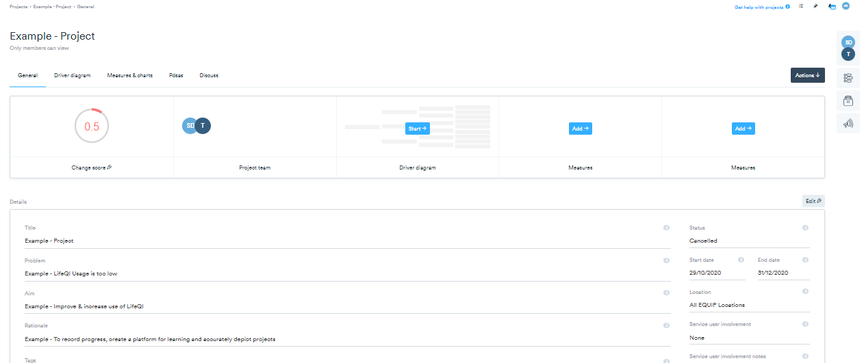
Select the Timeline icon.

- You will notice that the status change has been logged.
  - Click “Add to the timeline”

  - Select the type of event as “status update” and then select Next.
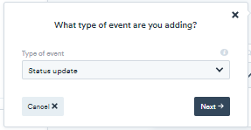

  - Type in the reason for you status update and the date the project update will take effect. In this example we have given our cancellation reason.

Select Create event
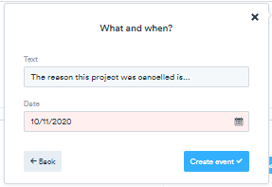

Your timeline will now be updated.

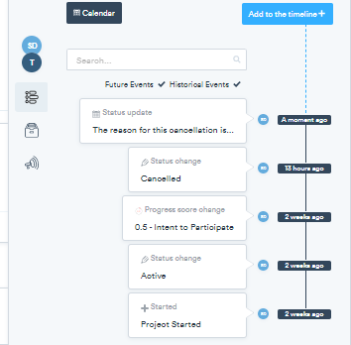

Version Control
Name | Email | Date | Version
Sindbad Dwomoh | s.dwomoh@nhs.net | 17/11/2020 | 1.0

