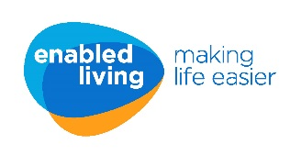
Deaf Awareness and introduction to British Sign Language (BSL) – Nov 2023

Our course is delivered by Deaf trainer Audrius Kiminius from BSL Now! alongside a communication worker.

Course Aim:
Our Deaf Awareness and introduction to British Sign Language (BSL) course teaches you how to communicate with Deaf people and how to use basic BSL in everyday situations. During the course you will cover a variety of different topics including numbers & time, home and travel and the beginnings of a conversation.

Course outcomes:
By the end of the course learners will:

- Have an awareness and understanding of Deaf culture
- Understand the barriers faced by people with hearing loss
- Feel confident about communicating with people who are deaf or have hearing loss
- Understand that regions within the UK use different signs for words
- Be able to recognise and sign the alphabet and numbers
- Be able to ask and recognise and sign questions e.g. what, why, who, whose, how, how much, when?
- Be able to sign basic greetings and the beginning of conversations

Date: Every Thursday for six weeks - (All dates must be attended)

Thursday 2nd November
Thursday 9th November
Thursday 16th November
Thursday 23rd November
Thursday 30th November
Thursday 7th December

Time: 3pm – 5pm

Venue: The Enabled Living Lounge, 200 Chargeable Lane, Plaistow E13 8DW

Cancellation and non-attendance:
This course is fully funded by Enabled Living however failure to attend all six dates will incur a £50.00 cancellation charge.

Application Form

Course: Deaf Awareness and introduction to British Sign Language (BSL)

Course dates:
Thursday 2nd November
Thursday 9th November
Thursday 16th November
Thursday 23rd November
Thursday 30th November
Thursday 7th December

Full name
Work Address
Work email
Contact telephone
Sign
I understand a £50.00 fee will be charged for non-attendance
Date

Please return your form to: Uzma.Khankhara@enabledlivinghealthcare.co.uk

